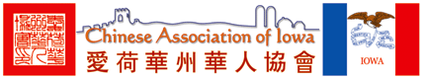
Chinese Association of Iowa
2520 Vine St., West Des Moines, Iowa 50265
Phone: 515-988-0901 | Email: IowaChinese@yahoo.com | Web: www.iowachinese.org

News Release
Swallow Yan, Executive Director
Chinese Association of Iowa
2520 Vine St, West Des Moines, Iowa 50265
Phone: 515-988-0901 | Email: IowaChinese@yahoo.com | Web: www.IowaChinese.org

Feb. 14, 2010

On Feb. 13, 2010, the Chinese Association of Iowa hosted the 8th annual Iowa Chinese New Year Celebrations and Iowa Chinese Achievement Award Ceremony at Indian Hills Junior High School, Clive. Over 1,200 community members participated the events.

Des Moines Register reported the largest Chinese New Year celebrations hosted by the Chinese Association of Iowa. The performing groups from Hebei, Omaha, Kansas City, Ames, and greater Des Moines areas demonstrated their excellent cultural programs. The report is as following:

Asian-American groups celebrate Lunar New Year

By REID FORGRAVE • rforgrave@dmreg.com • February 14, 2010

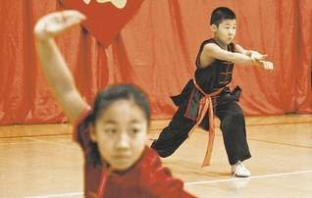
ANDREA MELENDEZ/THE REGISTER
Joseph Zhang, 10 and Sarah Mu, 11, of Omaha perform a kung fu routine at the Chinese New Year celebration Saturday at Indian Hills Junior High in Clive.

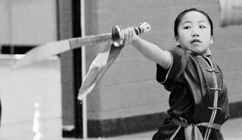
ANDREA MELENDEZ/THE REGISTER
Sarah Mu, 11, of Omaha performs a kung fu routine at the Chinese New Year celebration at Indian Hills Junior High School in Clive. The Year of the Ox ended and Year of the Tiger began Saturday, according to the Chinese calendar.

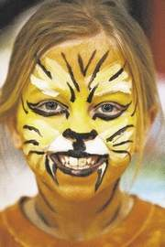
ANDREA MELENDEZ/THE REGISTER
Leah Hunter, 8, of Clive had her face painted like a tiger for the Chinese New Year celebration. Dancing, traditional music
and food were also part of the party.

The Year of the Ox ended Saturday and brought the Year of the Tiger, and two Asian-American cultural celebrations in central Iowa honored the coming of the Lunar New Year.

At Indian Hills Junior High School in Clive, hundreds of Iowans across ethnic lines came to celebrate the Chinese New Year.

A group of elementary-age girls, their faces painted like tigers, showed off their acrobalance skills, doing moves called the "high straddle" and "bridge over troubled water." Kung fu practitioners put on a demonstration.

And artist Guang Young, a native of China who now lives in Urbandale, asked 4-year-old Addyson Kastli if she wanted her name written in Chinese characters on the back of the painting her aunt just bought her. (She did.)

Young was selling miniature paintings of each of the 12 animals from the Chinese zodiac.

"New Year's means so much. It means families get together, sort of like Christmastime in American culture," Young said. "We all do miss China this time of year."

Nearby, Dongni Ye, a junior triple-major at Drake University, played a four-stringed guitar-like Chinese instrument called a pipa. Her parents live in Chongqing, a major city in central China.

"Chinese New Year is kind of hard for me," she said. "It's about family togetherness, and lots of food. I called my family this morning. It's already the new year in China."

At Westminster Presbyterian Church in Des Moines, a group of 150 Korean-Americans and others interested in Korean culture gathered for a traditional Korean New Year's meal: kimchi, rice cake soup, fried sweet potatoes, and more.

Some of the attendees were Iowans who have adopted Korean children. Others were Iowans whose interest in Korean culture stemmed from tae kwon do.

"New Year's is symbolic of a new day, a new life," said Korean immigrant Kummsan Song, a retired doctor. She explained that Korean tradition is to have your house cleaned and your debts paid before every new year.

One of the organizers of Korean Lunar New Year celebration, Jenny Chung of Johnston, is a first-generation Korean immigrant whose parents moved to Iowa when Chung was young.

Chung rejected her heritage as a child growing up in Iowa, refusing to speak Korean with her parents and not being proud of being Korean. Her parents founded the Korean Cultural Center a decade ago, and Chung has become proud of her heritage since then.

At Saturday's celebration, Chung stood by the "charye sang," or a feast table that honors ancestors.

"My mom has the history, the culture, the knowledge, and she wants to pass it down to people like me," Chung said. "We want to teach kids about their heritage and culture so they'll be proud of it."

